# Supplementary Information

## Supplementary Information 1 – Richness and niche specialization model output

Additional details for models predicting species richness (section A) and models predicting mean niche specialization (section B). Spatial autocorrelation results (correlograms) for best models of the respective analysis are presented in section C.

### Section A: Richness model output

(i) Analysis of variance table output for fixed effects of models predicting species richness. We report mean square (MS), degrees of freedom (df), F-values (F), and p-values. Models also included Year as random effects. Polynomial models are 2nd order polynomial. HD is human development extent, Protocol is the sampling protocol used by ABMI technicians to assess vascular plant occurrences, and Nonnatives is the proportion of nonnative species.

|  |  |  |  |  |  |
| --- | --- | --- | --- | --- | --- |
| Model | Fixed effect | df | MS | F | p-value |
| Linear | HD | 1 | 3254 | 14.4 | <0.001 |
|  | Protocol | 1 | 52408 | 231.5 | <0.001 |
| Polynomial | HD2 | 2 | 11616 | 54.3 | <0.001 |
|  | Protocol | 1 | 57982 | 271.0 | <0.001 |
| Polynomial x Nonnatives | HD2 | 2 | 4741 | 23.1 | <0.001 |
|  | Protocol | 1 | 61350 | 298.5 | <0.001 |
|  | Nonnatives | 1 | 10738 | 52.2 | <0.001 |
|  | HD2 x Nonnatives | 2 | 1468 | 7.1 | 0.001 |

(ii) Chi-squared likelihood ratio test of the (a) linear and (b) second order polynomial models predicting species richness. We report degrees of freedom (df), AIC scores, log-likelihoods (LL), and Χ2 and p-values for the better model. Residuals of the best (polynomial) model displayed very weak spatial autocorrelation (Moran’s I = 0.04, p < 0.001).

|  |  |  |  |  |  |
| --- | --- | --- | --- | --- | --- |
| Model | df | AIC | LL | Χ2 | p-value |
| Linear | 5 | 13095 | -6542.7 |  |  |
| Polynomial | 6 | 13007 | -6497.3 | 90.67 | <0.001 |

(iii) Chi-squared likelihood ratio test of the polynomial and polynomial interaction (i.e. HD2 x Nonnatives) models predicting species richness. We report degrees of freedom (df), AIC scores, log-likelihoods (LL), and Χ2 and p-values for the better model.

|  |  |  |  |  |  |
| --- | --- | --- | --- | --- | --- |
| Model | df | AIC | LL | Χ2 | p-value |
| Polynomial | 6 | 13007 | -6497.3 |  |  |
| Polynomial x Nonnatives | 9 | 12948 | -6464.8 | 65.04 | <0.001 |

### Section B: Realized niche specialization model output

(i) Analysis of variance table output for fixed effects of models predicting realized niche specialization. We report mean square (MS), degrees of freedom (df), F-values (F), and p-values. Models also included Year random effects. HD is human development extent and Protocol is the sampling protocol used by ABMI technicians to assess vascular plant occurrences.

|  |  |  |  |  |  |
| --- | --- | --- | --- | --- | --- |
| Model | Fixed effect | df | MS | F | p-value |
| Linear | HD | 1 | 2.83 | 127.0 | <0.001 |
|  | Protocol | 1 | 0.35 | 15.7 | <0.001 |
| Polynomial | HD2 | 2 | 2.55 | 121.8 | <0.001 |
|  | Protocol | 1 | 0.20 | 9.8 | 0.002 |

(ii) Chi-squared likelihood ratio test of the linear and polynomial models predicting species specialization. We report degrees of freedom (df), AIC scores, log-likelihoods (LL), and Χ2 and p-values for the better model. Residuals of the best (polynomial) model displayed very weak spatial autocorrelation (Moran’s I = 0.07, p < 0.001).

|  |  |  |  |  |  |
| --- | --- | --- | --- | --- | --- |
| Model | df | AIC | LL | Χ2 | p-value |
| Linear | 5 | -1501 | 755.4 |  |  |
| Polynomial | 6 | -1570 | 807.2 | 103.63 | <0.001 |

### Section C: Spatial autocorrelation of model residuals

Analyses performed using correlog function in the pgirmess package (Giraudoux 2018) in R.

Patrick Giraudoux (2018). pgirmess: Spatial Analysis and Data Mining for Field Ecologists. R package version 1.6.9. https://CRAN.R-project.org/package=pgirmess

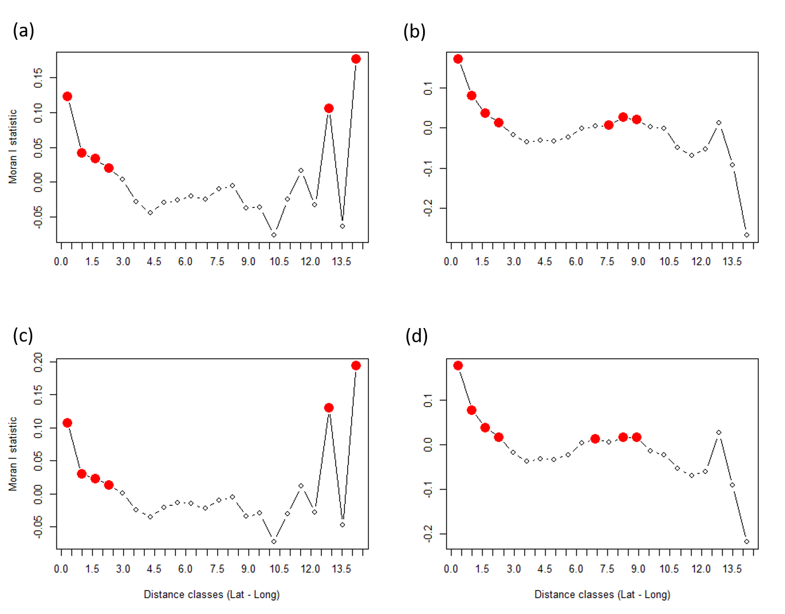

Supplementary Figure 1. Correlograms of the residuals of best models: (a) Richness polynomial HD model, (b) Richness polynomial HD * Nonnatives proportion model, (c) Specialization polynomial HD model and (d) Specialization polynomial HD * Nonnatives proportion model. Red dots show significant Moran's I indices. Overall, significant values of Moran's I indices across distance classes are weak (< 0.2) for all model residuals, indicating weak spatial autocorrelation biases.

## Supplementary Information 2 – Comparisons across human development levels

Additional details for human development levels (section A), community composition (section B), and niche specialization (section C) across low, intermediate, and high human development levels.

### Section A: Summary of human development levels

Summary of sampling, vegetation, and human development attributes of wetlands in Alberta surrounded by low, intermediate, and high human development (HD) levels. Wetlands surrounded by 0%, 45-55%, and ≥90% total human development extent were categorized as being surrounded by low, intermediate (Int.) and high human development levels respectively. For each level, we report the number of sites (No. sites) and the median (and interquartile range) human development extent (HD extent), vascular plant richness, proportion of nonnative species, and site-level niche specialization index.

|  |  |  |  |  |  |
| --- | --- | --- | --- | --- | --- |
| HD level | No. sites | HD extent (%) | Richness | Nonnatives (%) | Niche specialization |
| Low | 435 | <0.1 (0.0) | 34 (19) | 0.0 (1.7) | 0.75 (0.21) |
| Int. | 53 | 50.2 (4.3) | 36 (26) | 14.0 (18.7) | 0.58 (0.15) |
| High | 125 | 97.5=7 (6.8) | 27 (18) | 35.9 (27.5) | 0.61 (0.19) |

### Section B: Community composition across human development levels

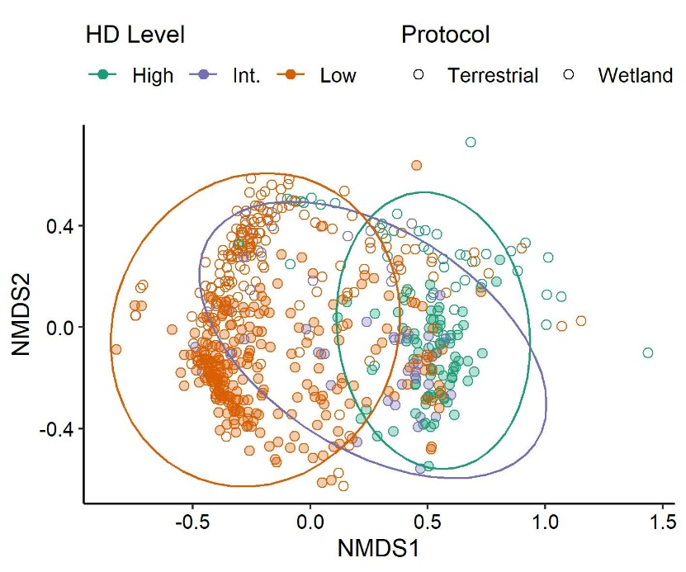

Supplementary Figure 2. Ordination of vascular plant community compositions for wetlands in Alberta. Each point represents the community of one wetland inferred from NMDS analysis. Points are colored by human development (HD) level and point properties (filled vs open) differentiate the sampling protocol. The low HD level includes n = 435 wetlands with 0% total human development extent; the intermediate (Int) HD level includes n = 53 wetlands with 45-55% human development extent; the high HD level includes n = 125 wetlands with ≥90% human development extent. Ellipses represent 95% confidence intervals for the centroids of the HD levels. The final ordination converged with 5 dimensions; stress was 0.08.

### Section C: Niche specialization across human development levels

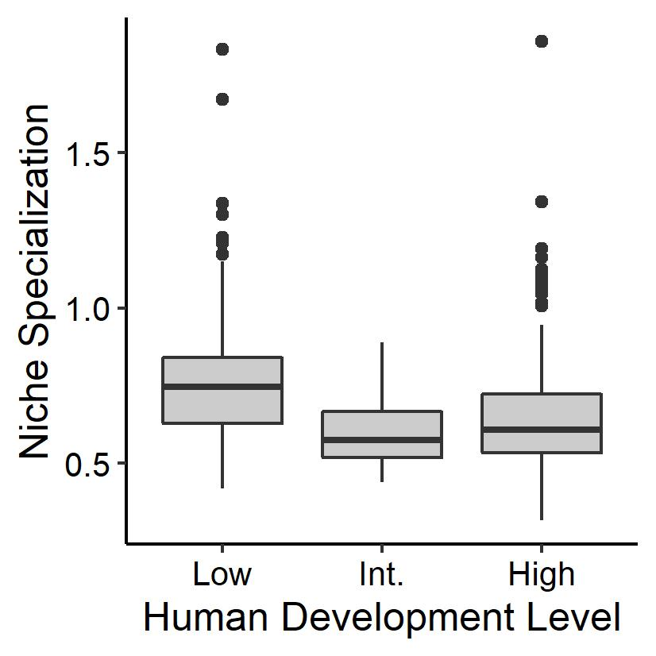

(i) Supplementary Figure 3. Median community-level niche specialization differs significantly across sites with low, intermediate (Int.) and high human development levels (ANOVA of mixed effects model F = 20.81, p < 0.001). Solid thick horizontal lines depict the median niche specialization, the boxes extend to the first and third quartiles, and whiskers extend to 1.5 times the interquartile range.

(ii) Post-hoc pairwise comparisons of niche specialization for sites surrounded by low, intermediate (Int.), and high human development (HD) levels.

|  |  |  |
| --- | --- | --- |
| HD level comparison | Difference in means | p-value adjusted |
| Low-Int | 0.132 | < 0.0001 |
| Low-High | 0.077 | < 0.0001 |
| Int-High | -0.055 | 0.123 |

## Supplementary Information 3 – Nonnative species richness across human development gradient

The proportion of nonnative wetland vascular plant species increases across the human development gradient (see Figure 3a and text). This pattern may occur if (a) the number of nonnative species (i.e. nonnative richness) is constant across the human development gradient but native richness declines, (b) nonnative richness increases with increasing human development but native richness is constant, or (c) nonnative richness increases across the human development gradient coincidently with a decline in native richness. Using mixed effects models as described in the Methods, we find support for c, where nonnative richness increases over the human development gradient (marginal R2 = 0.40, conditional R2 = 0.40) and native richness declines after ~25% human development extent (marginal R2 = 0.22, conditional R2 = 0.25). This is in contrast to findings of Mayor et al. (2012) who found no statistical response of nonnative richness to human development in terrestrial plants. However, we caution against analyzing native and nonnative species richness separately, since these co-occurring taxa are not ecological independent.

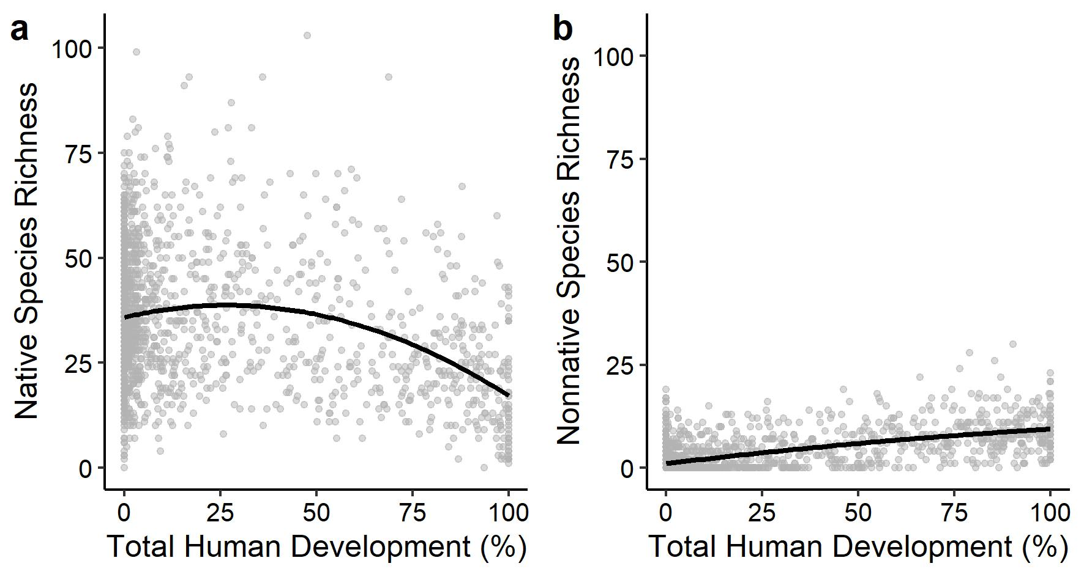

Supplementary Figure 4. In (a) the number of native species initially increases over the human development gradient then declines after ~25% human development, while in (b) the number of nonnative species increases over the human development gradient. Black lines represent the maximum likelihood fit of both the wetland and terrestrial protocols combined.

## Supplementary Information 4 – Accuracy of niche specialization indices

Additional details on the accuracy of niche specialization indices calculated using a randomization process with 1000 runs.

For rare species (i.e. those with few occurrences in our data set) at low human development extents, our random site selection process could skew the niche specialization index calculated from any single randomization run (see example of correlation between two random runs in Supplementary Figure 5, below). This would lead to higher variation in niche specialization indices calculated across runs for rare species at low human development gradients than for commoner species or for rare species occurring at higher human development extents. To assess which species exhibited high variation in niche specialization indices calculated across the 1000 randomization, and therefore low accuracy in their mean niche specialization index, we plotted the distribution of the ranges in niche specialization indices for all species. A species’ mean niche specialization index was considered to have low accuracy if the range in calculated values exceeded the 95th percentile (Supplementary Figure 6). All analyses were repeated after excluding these low-accuracy species (n = 37), and we found no change in the interpretation of the results. We therefore elected to report here the results from analyses that included all species, since the overall correlation across randomization runs was high and excluding low-accuracy species did not change the interpretation of the results.

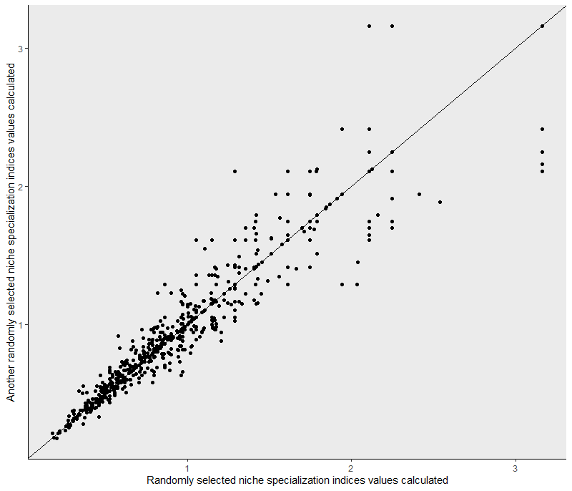

Supplementary Figure 5. Niche specialization indices calculated using a randomization process showed high correlation between runs. This figure shows the correlation for 2 randomly selected runs of 1000 total runs performed. The solid black line is the 1:1 line; niche specialization indices also clustered around the 1:1 line indicating that the indices calculated in different runs are not only correlated, but very similar. Note, however, the species with high niche specialization indices which deviate from the 1:1 line.

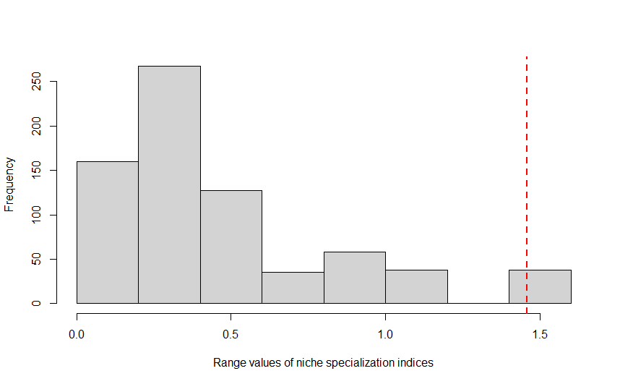

Supplementary Figure 6. Distribution of the range of niche specialization indices across 1000 randomizations for each species. The dashed red line indicates the 95th percentile threshold in the range of niche specialization indices (1.46) used to identify species (n = 37) with low accuracy in their mean niche specialization index.